Student’s Name
Professor’s Name
Course
Date
The brake pads
A brake pad is a component of a disk brake that is applied in automotive as well as in other related fields of mechanics. The pads generally function by converting the kinetic energy produced from the vehicle into thermal energy through frictional process. In the brake caliper exists two brake pads facing the rotor. In this case, when brake is applied, then the clamp squeezes the two pads towards each other forcing them to clinch on rotating rotor, therefore creating a frictional force, causing the vehicle to stop or slow down.
There different types of brake pads depending on the contents of design and the kind of automobiles for which they are purposed to perform. They include; the semi-metallic brake pads, low metallic brake pads, and the ceramic brake pads.
Semi-metallic brake pads
This is a type of brake pad system with up to 65% metal components. The metallic components include; wire, steel wool, copper, and other related metals with good qualities. The remaining friction surface is therefore made up of the modifiers, fillers and other materials that enhance quality and durability. This type of pad is considered durable, but its durability may cause wear of brake motors prematurely as a result of the heavy strength of the pads.
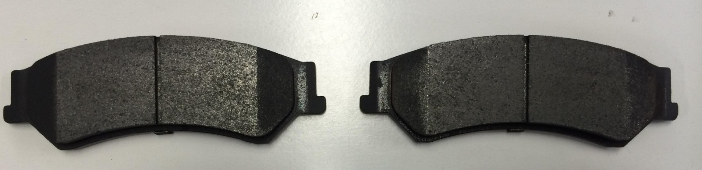
The semi-metallic are generally less expensive than the ceramic pads but much expensive than the low metallic brake pads (Talib, R. J., et al., p.47-52). It produces more energy that is then converted into the hydraulic system. In comparison to the other two brake pads, the semi-metallic brake pad is more sustainable; it lasts longer than the low metallic regarding functionality.
Analysis
- The relatively low average coefficient of friction; 0.28-0.38
- Poor wear at low temperatures, < 100c
- Maximum wear at high temperatures,> 200c
Low metallic brake pads
They are also referred to as the organic pads; it contains up-to 10% of metallic components in it. The materials used in making this kind brake pad include; high-temperature resins, plant fibers and other relevant materials such as glass. They contain Low-metallic Non-Asbestos Organic, which also contributes to the enhanced capability of the transfer of heat.
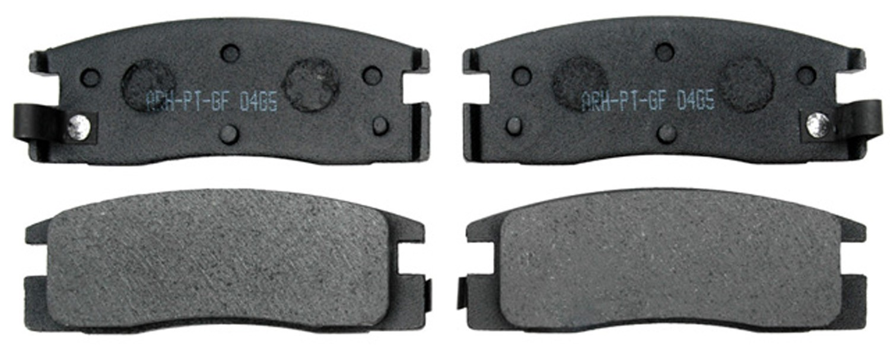
They tend to wear down faster and are always accompanied by the production of a lot of dust. This is due to their softness, the low level of metal. They are less durable compared of the three types of the brake pads (Lu, Yafei, p.814-823). Therefore are generally used for light purposes, for example in, low duty cars. They produce relatively low energy that is then transferred to the hydraulic system for breaking.
Analysis
- High coefficient of friction level; 0.38- 0.50

Ceramic brake pads
This type of brake pad contains dense ceramic materials that have kiln as the constituent. The kiln is mixed with copper and other fiber materials. These materials ensure its excellent performance in emergency brakes with very less noise and not much overheating. The pads are the best regarding performance. Just little strength applied, produces subsequent high energy in the shafts which then aids in the braking system. Its durability is also very long as compared to the other two. Generally, ceramics are used in automotive requiring sharp turnings, high racings like the high race vehicles.
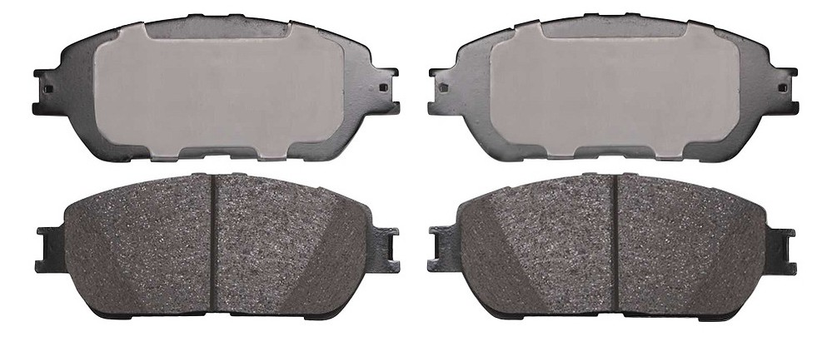
Analysis
- low to the medium-high coefficient of friction; 0.33-0.40
- maximum tear at relatively low temperatures < 200c

Jh
Type of wheel | material | Weight (g)/ piece | Manufacturing method | Cost  (RO)
Semi-metallic | - wire  - steel  - copper  - other metallic materials | 64 .2g | simulation method | - US$ 1.0-6.0/piece
Ceramic | - copper  - fiber material  - kiln constituents | 46.7 g | Green’s process. | -US$ 4.37-7.19/piece.
Low metallic | - resins  - glass  - partly fiber materials | 56.4g | Simplified cellular automation approach | - US $ 1.8- 3.0/piece.

From the tabulated data, it is clear that ceramic pads cost a lot, it is light and as well the best quality brake pad. The semi-metallic brake pad, which is commonly used by many people, has a lot of weight, due to many metallic components in it and costs averagely cheap as compared to the ceramic(Eriksson, p.163-167). Finally, the low metallic brake pad has moderately low weight as compared to the semi-metallic, very cheap due to the material contents that are used to design it.

Works Cited
.
Eriksson, Mikael, Filip Bergman, and Staffan Jacobson. "Surface characterization of brake pads after running under silent and squealing conditions." Wear 232.2 (1999): 163-167.
Lu, Yafei. "A combinatorial approach for automotive friction materials: combined effects of ingredients on friction performance." Polymer composites 23.5 (2002): 814-823.
Talib, R. J., et al. "Adaptability of activated carbon from palm oil kernel shell in the development of brake friction materials." AIP Conference Proceedings. Vol. 1901. No. 1. AIP Publishing, 2017

